PST – 1 ASSIGNMENT – 2

1.Write the program to evaluate the expression 4>3>2, 2+3>4+5 , 6>3+2<5

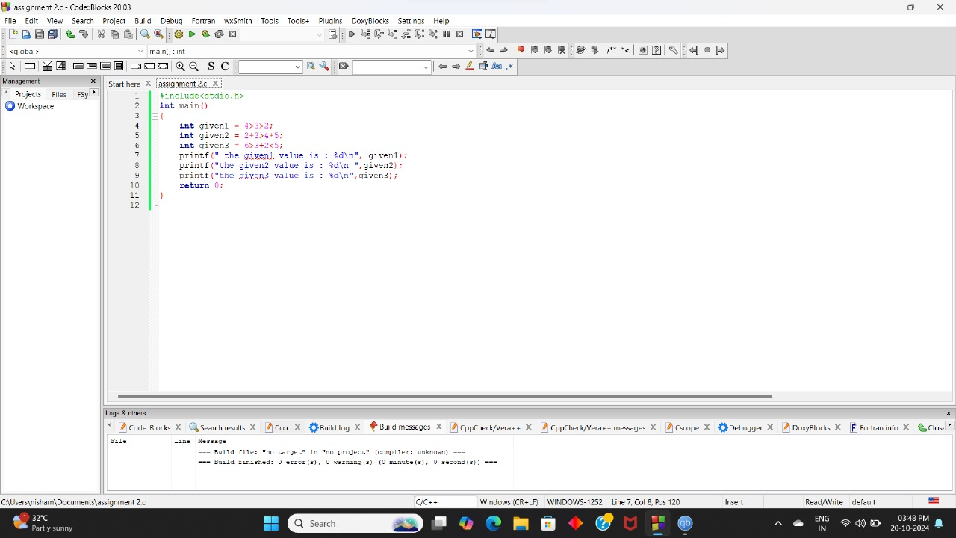

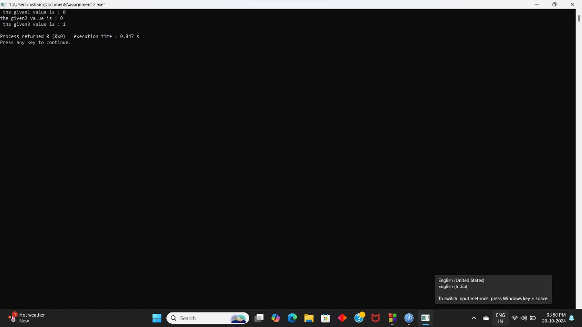

2.Write the program to evaluate the expression 5+3\*5>=25%2<=8=5-3\*2>=8+3!=5

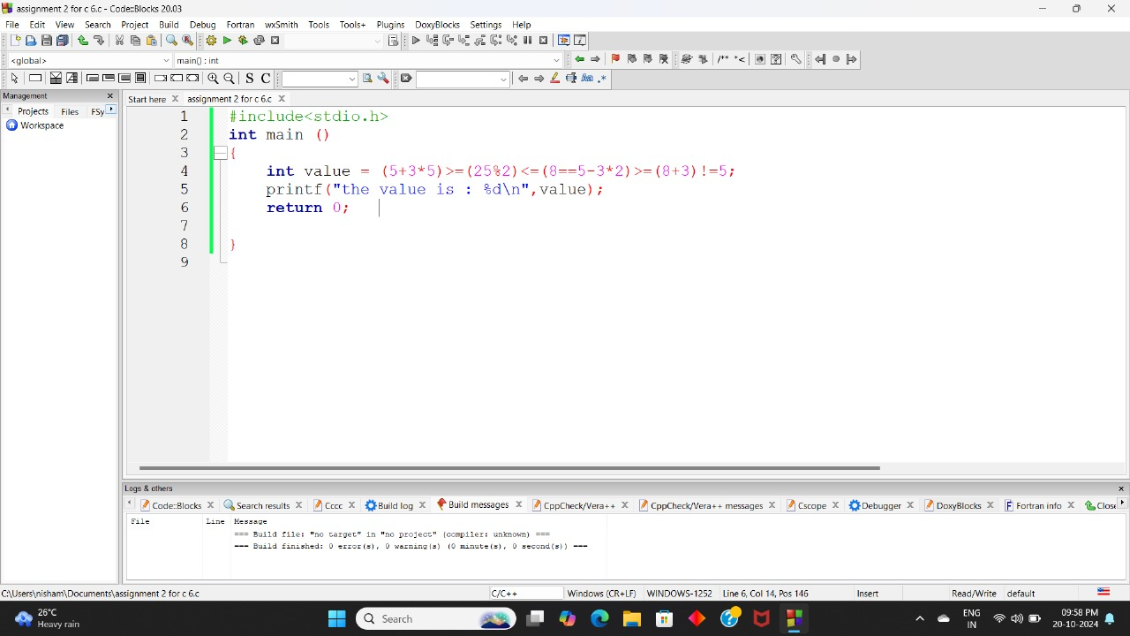

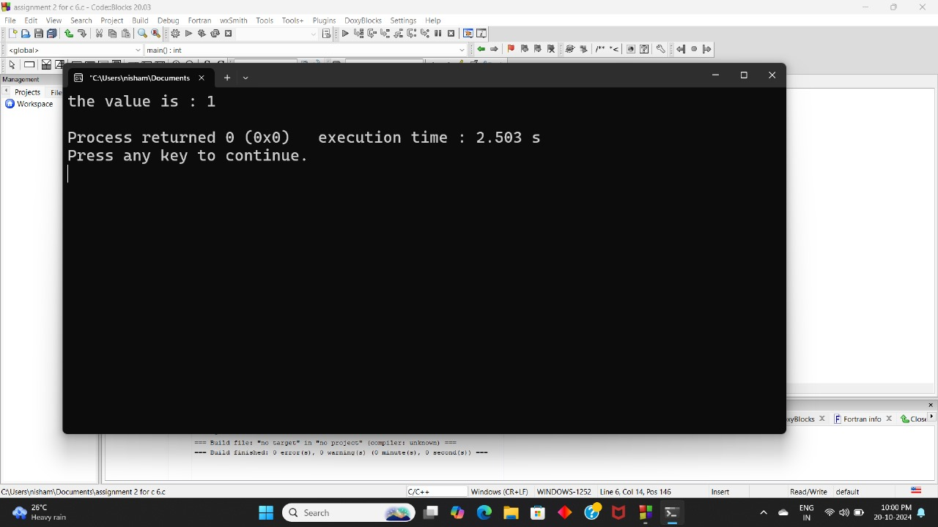

3. Write the program to evaluate the expression 10 && 8 ,0 && 8,0 && 0, 8 && 0

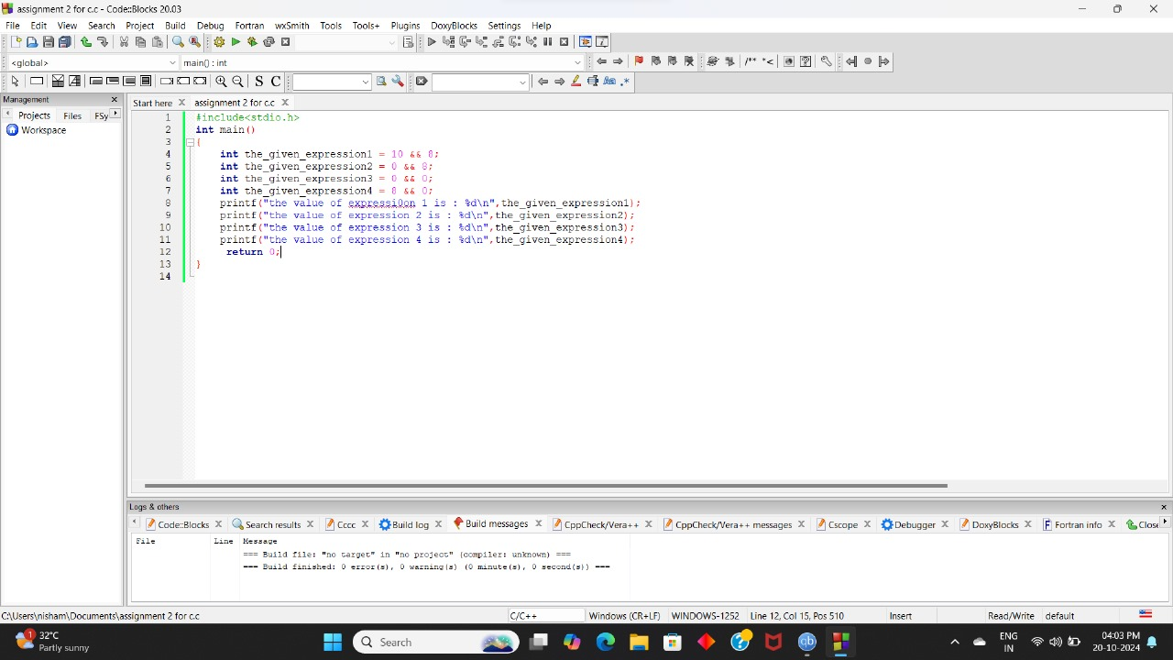

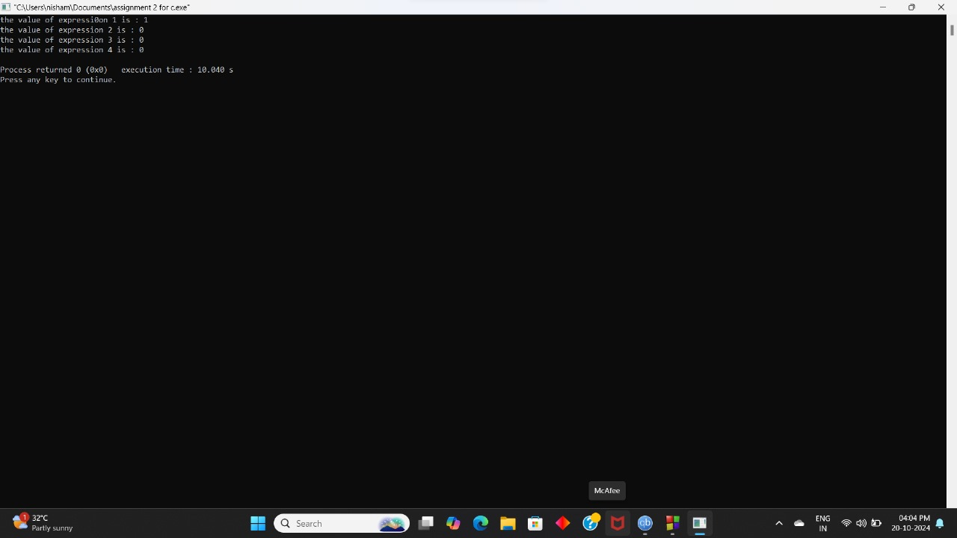

4. Write the program to evaluate the expression ! -8, ! 100 ,! 0,! 0.0

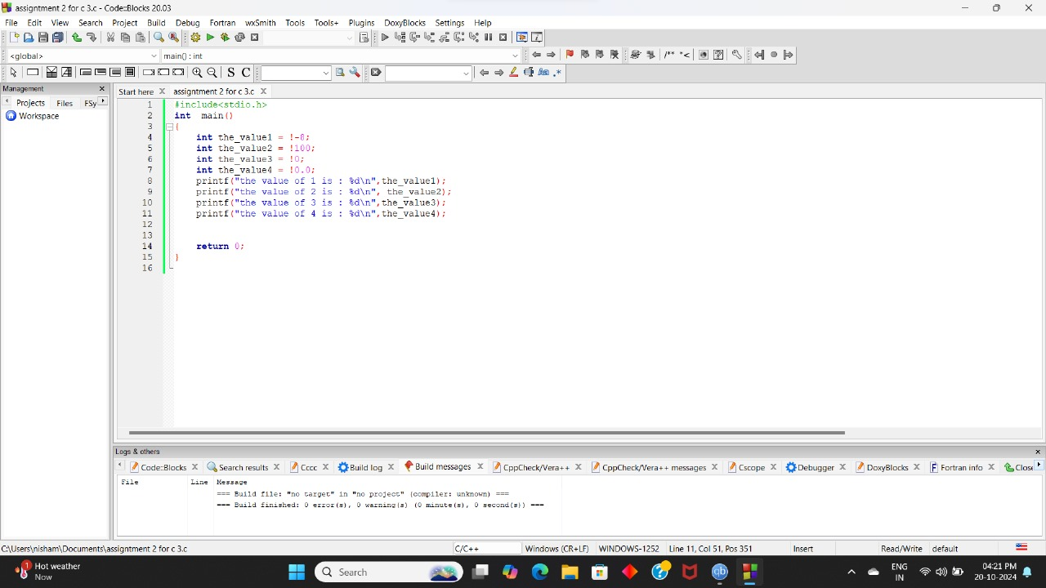

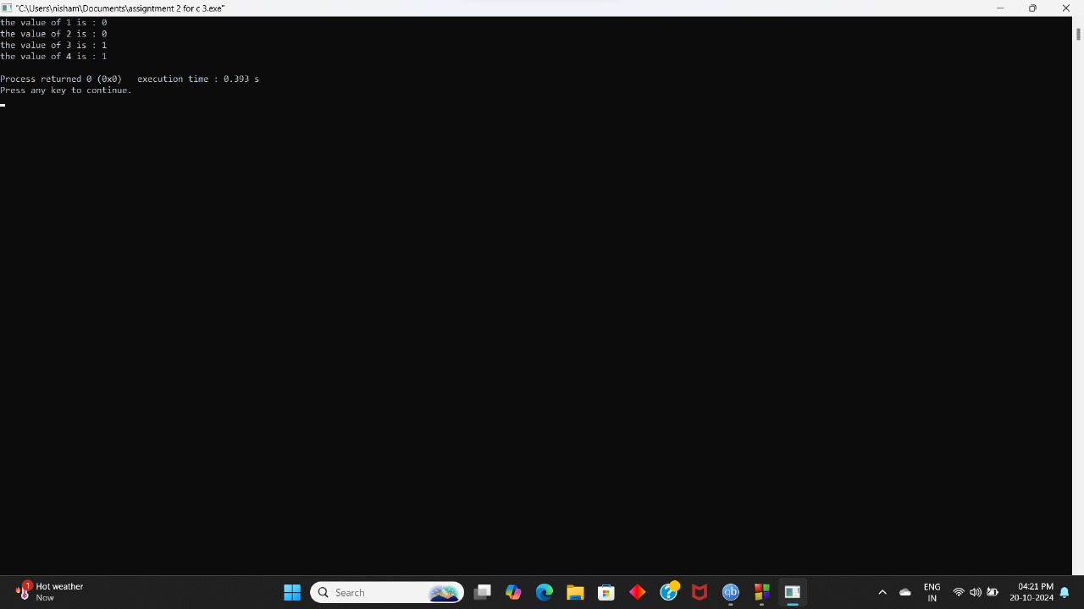

5.Write a program for left shift with 4 shifts <<=4 and right shift with 3 shifts >>=3

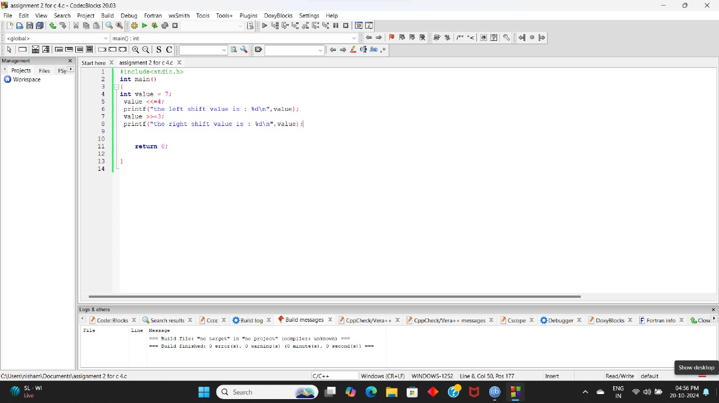

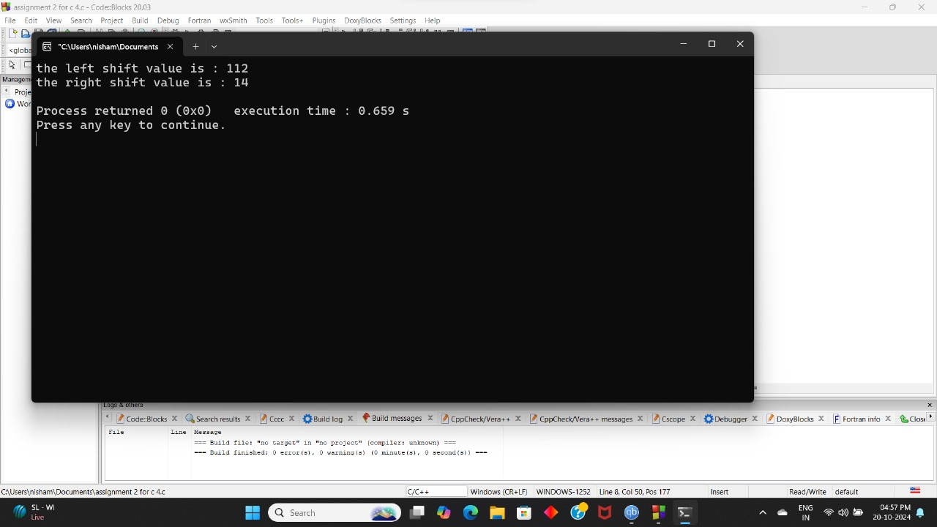

6. Write the program to evaluate the expression

4 > 5 , 4 < 5, 4 >= 5, 5 = 5, 4 == 5,

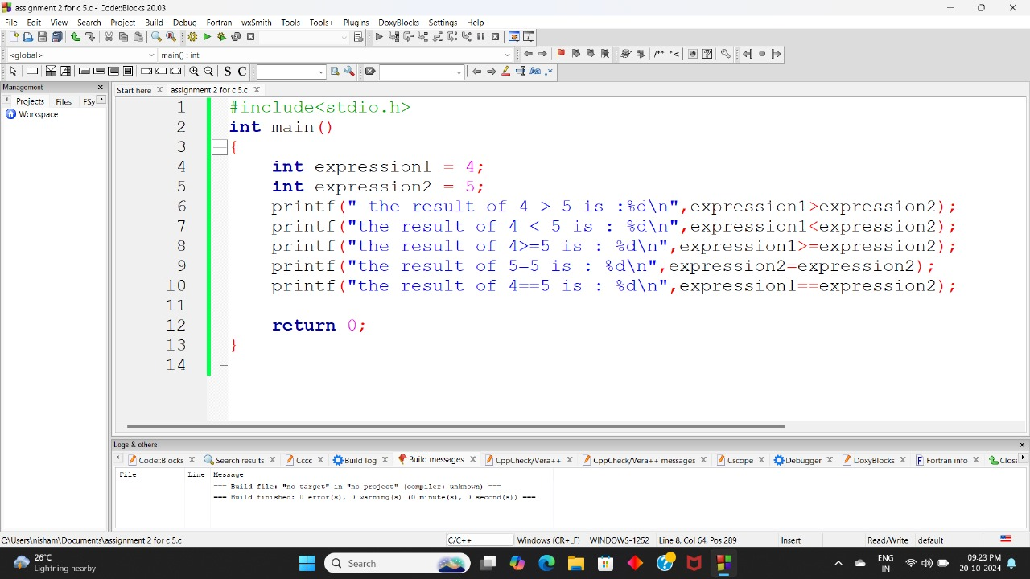

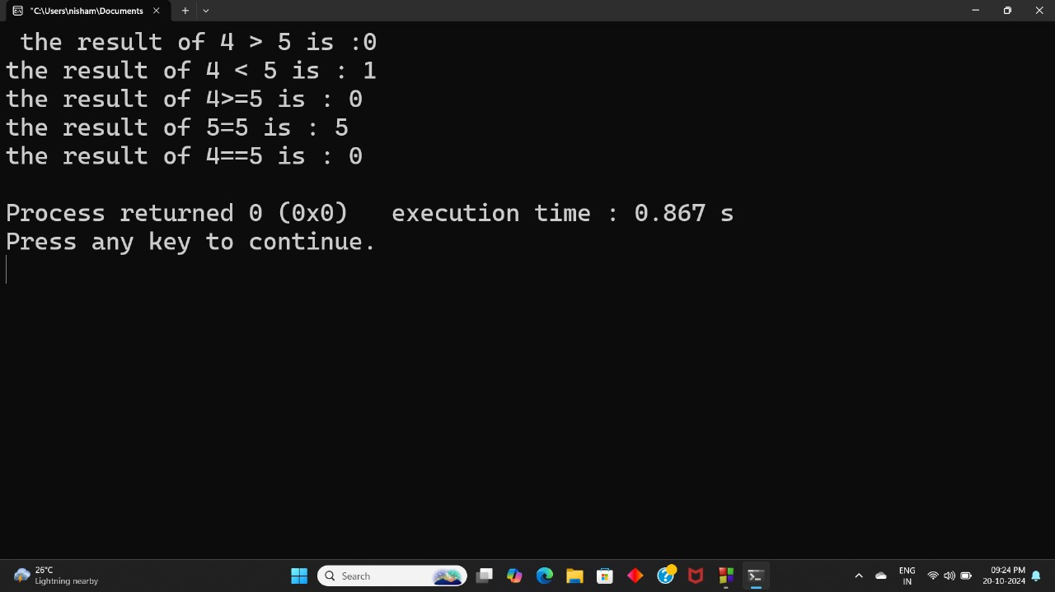

7. Write the program to evaluate the expression 4>3 && 3>2

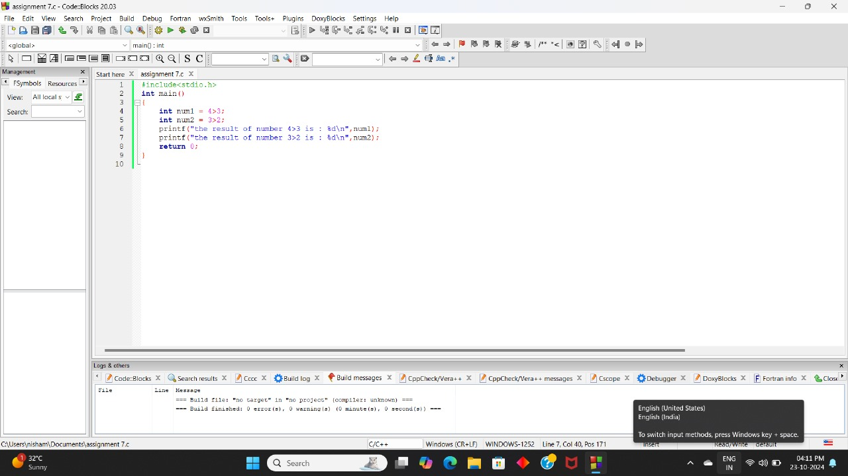

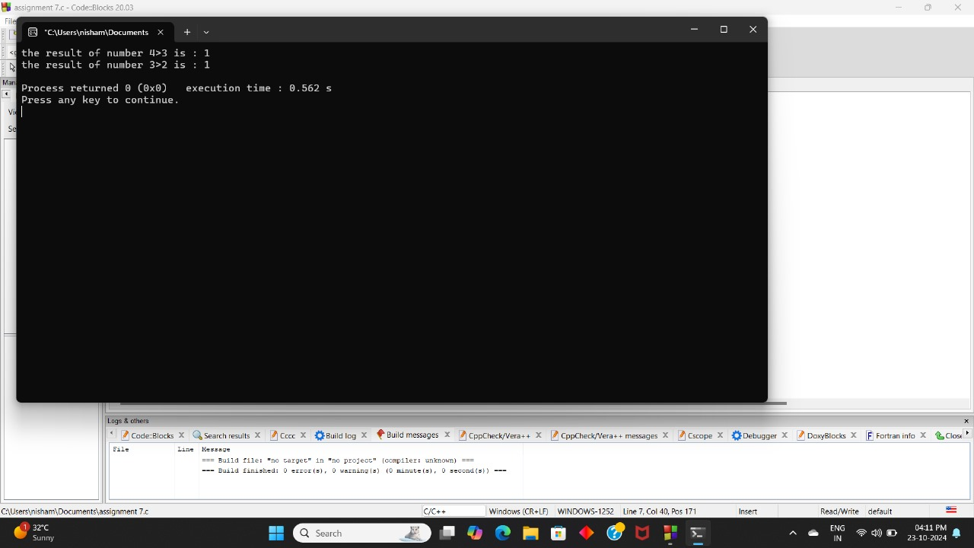\

8. Write the program to evaluate the expression !!!!a

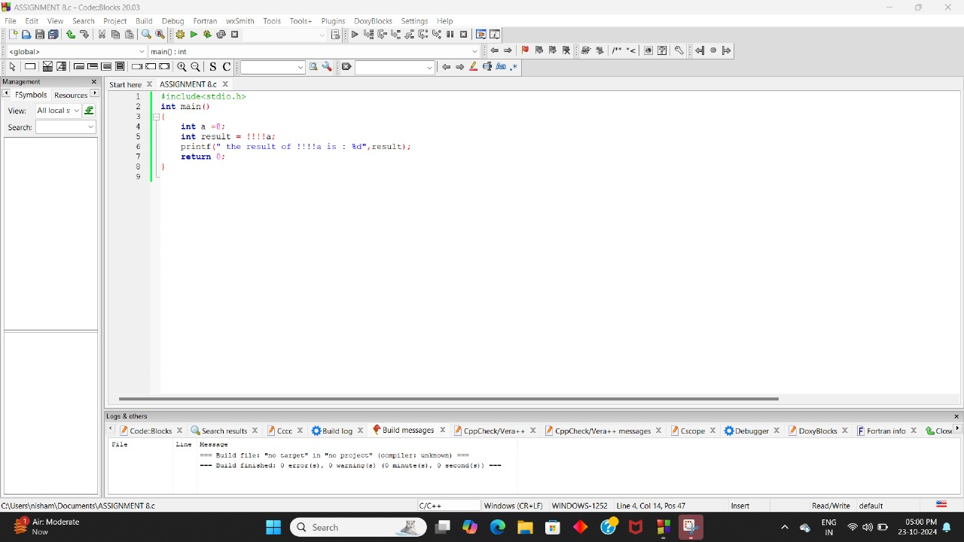

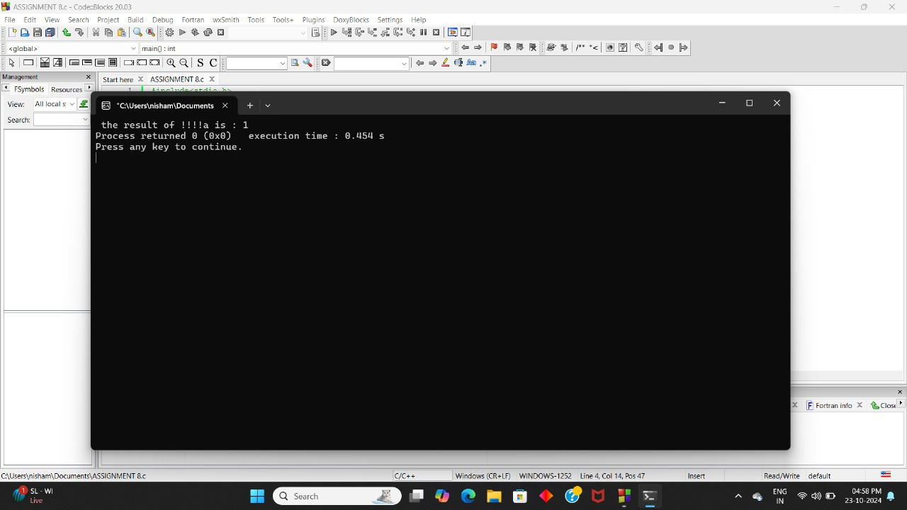

9.How many tokens in the given program and what are the tokens.

#include<stdio.h>

Int main()

{

Int num=10,num=20,num3=0;

num3=num1+num2;

printf(“%d”,num3);

return 0;

}

ANSWER :

TOTALLY 38 TOKENS ARE THERE ARE 37 TOKENS

#INCLUDE , <STDIO.H>

KEYWORDS : int , return

IDENTIFIERS : main,num1,num2,num3,printf

PUNCTUATION: (),{},(,),;,%d

CONSTANT : 10 20 0

OPERATORS : + , =

10.Write a program to divide two numbers without using / operator.

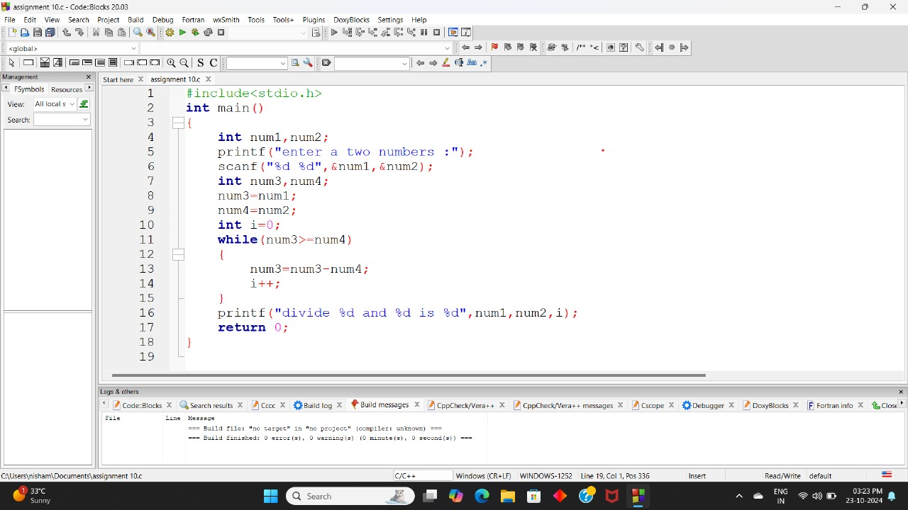

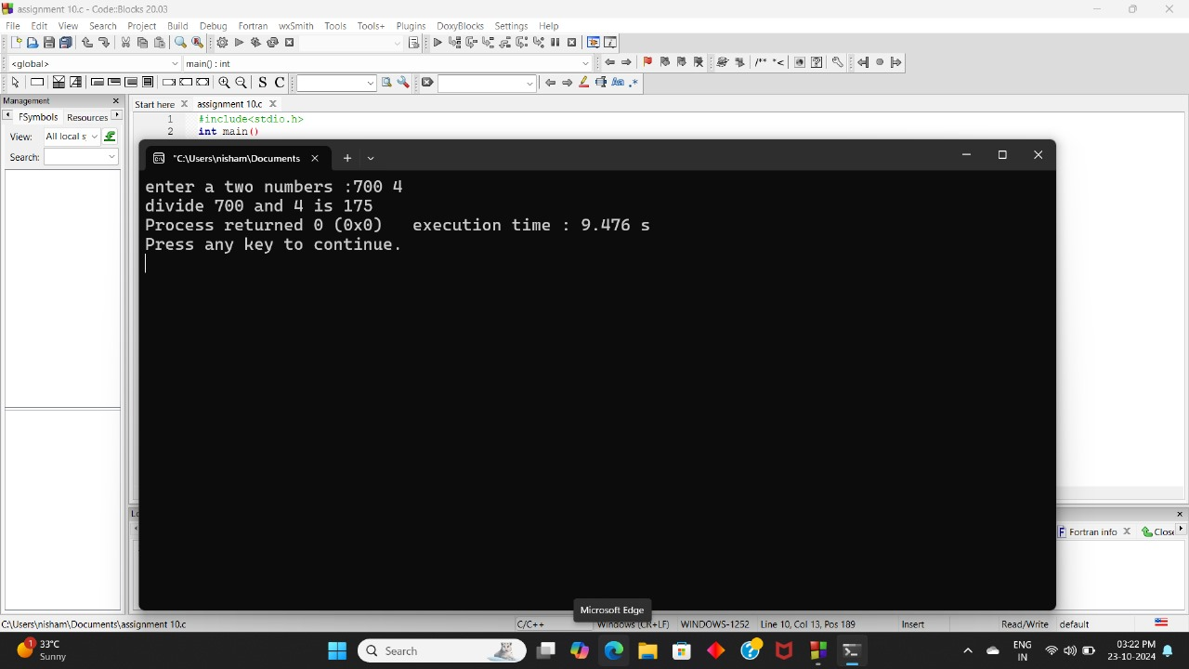

Application 8:

Write the c program airways,get user input for different classes in the airways,no of seats in each

class,fare for each class and calculate total.

